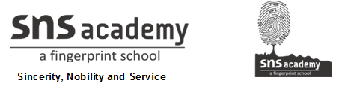

SOCIALSTUDIES
NAME:
GRADE: V DATE: 28.10.20
WORKSHEET - 13
13. LET US MEET

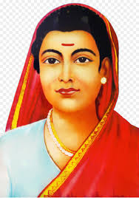
I.Look at the picture .Answer the questions

1. Identify and write the name of the personality.

2. When did she found the first girls school in Pune?

3. Write two protests against the women education.

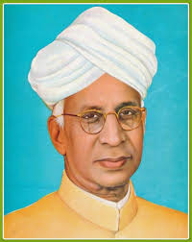

1. Identify and write the name of the personality.

2. When did he receive the India’s highest Bharat Ratna award?

3. Which day was celebrated as Teacher’s day?

II. Write true or false
1. Marie Curie discovered two elements. _____________.
2. Jane Austen wrote the novel Pride and Prejudice. _____________ .
3. M S Subbulakshmi was an sports person. _______________ .
4. Mary Kom was an artist. ____________ .
III. Match the following
1. Leo Tolstoy - Plastic surgeon
2. Martin Luther king Jr - Scientist
3. Jagadish Chandra Bose - Nobel peace prize
4. Sushruta - war and peace

